

Lesson created by the GMU-ODU CSforAll Team. For more information about
this lesson and our CSforAll initiative, contact Dr. Amy Hutchison at achutchison1@ua.edu

Lesson 2: Sequencing |  | Grade Level: 1

Concept: Sequencing
Vocab:
- Sequencing
- Debugging
- Start blocks
- Stop block

Summary: In this lesson, students will learn and practice retelling stories and putting them in the correct sequence. They will also review coding blocks and learn two new blocks.
Lesson Objectives (learning targets): I can…

- Ask and answer questions about a story
- Retell a story with beginning, middle, and end
- Sequence a story with a beginning, middle, and end
- Debug a story
- Design a story sequence
- Put a story in the correct sequence

VDOE English Standard(s) | Computer Science Standard(s)
Communication and Multimodal Literacies:  1.1 The student will use oral communication skills.  e) Use increasingly complex sentence structures in oral communication.  i) Retell information shared by others.  Reading:  1.9 The student will read and demonstrate comprehension of fictional texts.  d) Describe characters, setting, and plot events in fiction and poetry.  g) Summarize stories and events with beginning, middle, and end in the correct sequence.  Writing:  1.13 The student will write to communicate ideas for a variety of purposes. | 1.1 The student will construct sets of step-by-step instructions (algorithms) both independently and collaboratively a. using sequencing; b. using loops (a wide variety of patterns such as repeating patterns or growing patterns); and c. identifying events.  1.3 The student will analyze, correct, and improve (debug) an algorithm that includes sequencing and simple loops, with or without a computing device.  1.4 The student will plan and create a design document to illustrate thoughts, ideas, and stories in a sequential (step-by-step) manner (e.g., story map, storyboard, sequential graphic organizer).

Materials
- Virtual Teacher Slides for L2G1

The resources below may benefit the flow of your lesson or serve as asynchronous resources. You may choose to upload these resources to your virtual environment prior to this lesson or utilize them as practice resources post-lesson.

- A copy of The Gingerbread Man or a video read-aloud of The Gingerbread Man (read aloud prior to lesson)
- ScratchJr Blocks
- Word Wall Cards
- Gingerbread Man Sequencing Cards
- Blank index cards (3 per student)

Lesson Structure and Activities
Warm-up/Bell Ringer Activity: (5-10 min)

NOTE: All slides for this lesson are scripted so that, if needed, you can see exact definitions and instructions for teaching this lesson in the notes at the bottom of the teacher slide deck.

Review what we learned about patterns and loops in lesson 1. Show the “computer science”, “computer”, “pattern”, and “loops” word wall cards (slide 6-9).
Introduction: (10 min)

- Listen to a song, ask students to think about the pattern of the song and notice what happens at the beginning, middle, and end of the song.
- Engagement & Interest: play “Milkshake” by Koo Koo Kanga Roo (3 minutes) (Slide 11)
- Guide students to think about the beginning, middle, and end of the song. What was at the beginning/middle/end? (slide 12-15)

Guided Instruction: (15 min)

- Play Beginning, Middle, End game: retell each part of the Three Little Pig story (You are welcome to use familiar stories that your class has recently read/studied in Reading or Writing Workshop.). Use three fingers to indicate the beginning, middle and end (Slide 17-24).
- Have students try retelling the story with a partner or independently (slide 25). Turn and Talk.
- If time permits, try another story (Goldilocks and the Three Bears) in the same way (slide 27-32).
- Have students try retelling the story with a partner or independently (slide 33).

Turn and talk with a partner or brainstorm independently. Students can do this whole group or if you use breakout rooms, you can use that option.

Slide 34 provides a scaffold for students while they retell.

Turn and talk with a partner or brainstorm independently. Students can do this whole group or if you use breakout rooms, you can use that option.
- Introduce Sequencing and Debugging (Slide 35-37)

For the sequencing activity below, we’ve selected The Gingerbread Man. It is helpful for your students to have read the book frequently prior to this lesson. You’re welcome to use a story and matching sequencing cards of your choice.

- Guide students to retell the Gingerbread Man across fingers .- You may choose to play video if students need a refresher or let students know the resource will be available as an asynchronous resource.
- Model how to retell the story across the fingers again (slide 38-43) and then ask students to try it with a partner or work independently.

Cue finger wiggling or other signal taught previously. Prompt students to raise hand.

Guided Practice & Independent Practice: (30 min)

- Debugging activity: Go through slides 44-52 at appropriate pace for students, ask what we need to do to put the story in the right order.
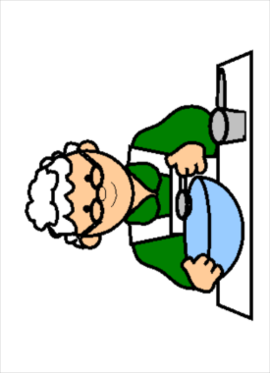
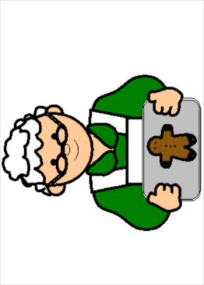
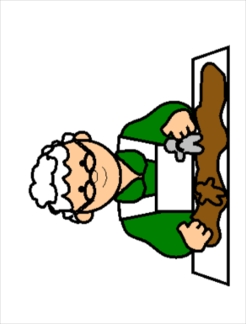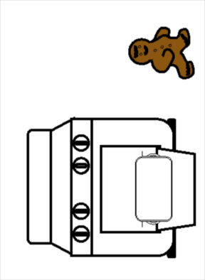

- Give some stories to students and let them choose one to identify the beginning, middle, and end, then shuffle them up and put the sequence out of order. Choose a few students to share their correct sequence (slides 53-54).

Consider displaying class read-aloud text ideas for students to choose from. Be sure to select stories that have a clear sequence, such as Goldilocks, the Three Little Pigs, The Little Red Hen, etc. ***If students have index cards available, encourage them to use them for this activity. Otherwise, ask students to get three pieces of paper or to draw three boxes on a piece of paper.

***Allow time for students to draw and write their sequencing cards. When finished, you can facilitate small groups or pairs for student teams to debug the sequence.

- CS connection: explain that sequencing is important in both writing and coding (slide 55).
- Introduce start and stop blocks (slides 56-59).

Wrap up: (2 min)

Review what we learned today by asking students to think about it and share (slide 60-61).
Provide opportunity for students to share their learning in small or whole group.
Assessment Strategy:
While students are working to create their own story sequence cards (and later sharing them with other groups or partners), check-in with groups or individually to ensure that students are a) retelling parts of the story to guide their thinking, b) retelling the story in the correct order, either across their fingers or by pointing to the pictures, and c) showing evidence of debugging the sequence.

Extension Ideas: | Art: Most arts and crafts activities naturally follow a beginning, middle, and end sequence. During your arts and crafts time, or while leading an arts and crafts center, explicitly integrate sequencing vocabulary. (e.g. “First, we have to paint the grass / We paint the grass at the beginning.”)  P.E.: Play a game of “follow the leader” in sets of 3 (e.g.hop, hop, jump). Prompt students to retell what action was done at the beginning, middle, and end of the sequence, either by describing it or acting it out.  Music: Young children typically enjoy clapping games that require observation, mimicking of the sound pattern, and opportunities to lead the patterns themselves. Model a clapping pattern for them to copy. Prompt students to retell/recreate which sounds were done at the beginning, middle, and end of the sequence  Writing: Sequencing can be embedded in writing through the creation of How-To books. Add simple 3-page booklets (more for advanced writers) to the writing center, allowing students to create their own 3 step How-To books with a beginning, middle, and end.  Science: Sequencing can be easily integrated into units on animals, weather, and life cycles. Embed sequencing vocabulary into lessons (e.g. “In the beginning, the butterfly lays an egg and a caterpillar hatches… In the middle, the caterpillar eats and eats and turns into a chrysalis… In the end, the butterfly comes out of the chrysalis.”)  Math: Kid-friendly cookbooks are an interesting, authentic place for children to see not only sequencing through steps, but also numbers and measurement. Consider adding cookbooks to the kitchen area during dramatic play.  Reading: Word families also have patterns at the end of the word that helps us to read and spell. Hone students’ visual discrimination by asking them to find words in a poem, book, or sort that end the same way.  Rationale:  Explicitly embedding vocabulary is an essential component of sequencing instruction. Young learners need repeated exposure to sequencing vocabulary in order to internalize the “flow” of stories and events.
Alignment: | This is the second lesson in the unit. Lesson 3 is Decomposition and Abstraction.
Supplemental Resources: | If time allows, or you wish to extend the lesson over multiple days, consider allowing students to draw and write a story sequence. You may choose to use the Beginning, Middle, End graphic organizer for students to sequence and retell the beginning, middle, and end of a story, or you could simply fold a piece of paper into thirds. Either way, encourage students to retell the story aloud to partners in breakout groups or have students volunteer to share virtually whole group, pointing to each picture or using their fingers to highlight the beginning, middle, and end of the story.

