Answer Key, Patterns and Sequencing Review

- Which instructions take ‘Pac-Man’ to the ghost by the path marked out?
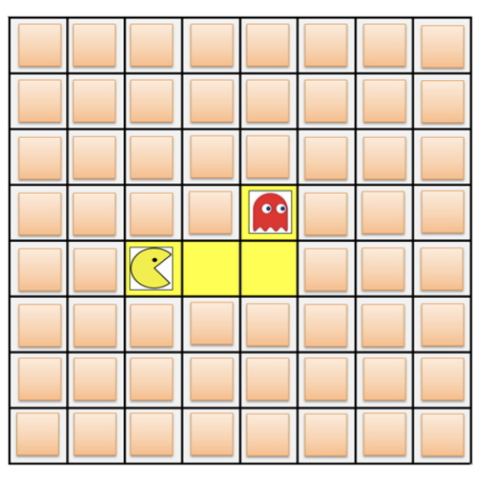

2. Which instructions take ‘Pac-Man’ to the ghost by the path marked out?
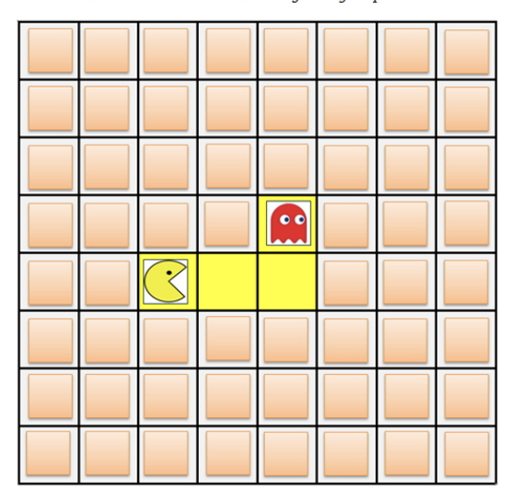
- 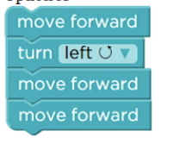
- 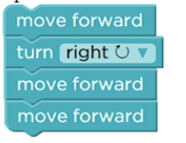
- 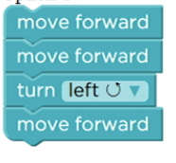
- 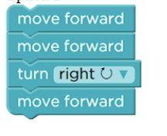

3. Which instructions should the artist follow to draw the shape? The short measures 50 pixels and the long side measures 100 pixels.
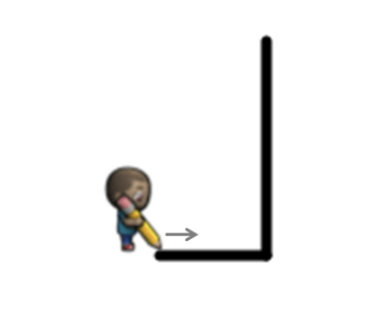

- 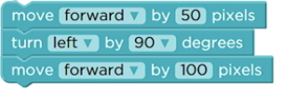
- 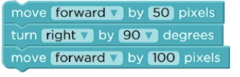
- 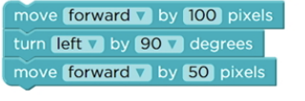
- 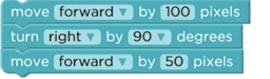

4. Which instructions take ‘Pac-Man’ to the ghost by the path marked out?
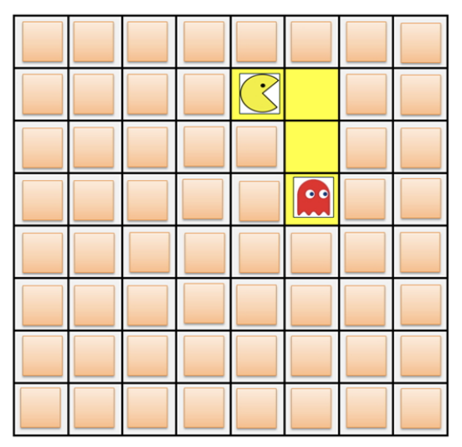

5. Which step is missing in the instructions below to take the ‘Pac-Man’ to the ghost by the path marked out?
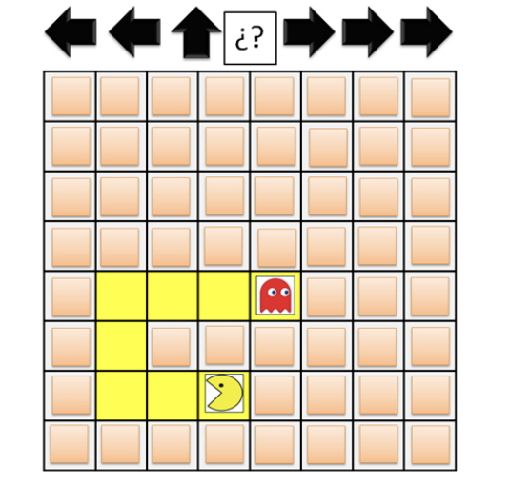

6. The instructions should take the ‘Pac-Man’ to the ghost by the path marked out. In which step of the instructions is there a mistake?

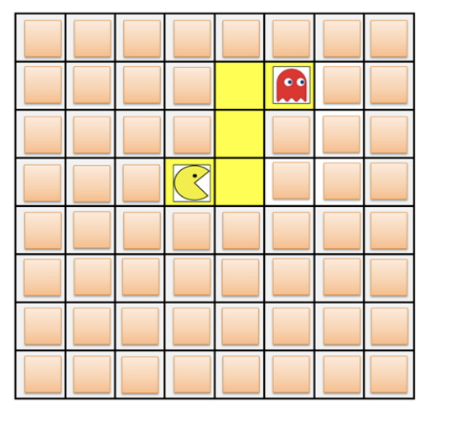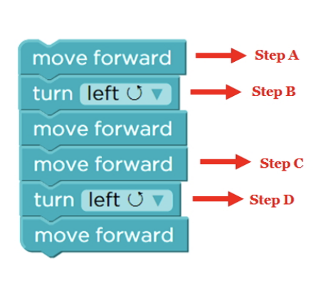

- Step A
- Step B
- Step C
- Step D

