**How to Create a Studio & Share Students’ Scratch Products**

**Creating a Studio**

1. Sign in to your Scratch account at <https://scratch.mit.edu/>
2. Click on “My Classes”.



1. Click “Studios” under the class that you want to share.

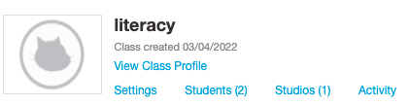

1. Click “+ New Class Studio”.



1. Add a “Studio Name” and “Studio Description”, then click “Add Class Studio”.

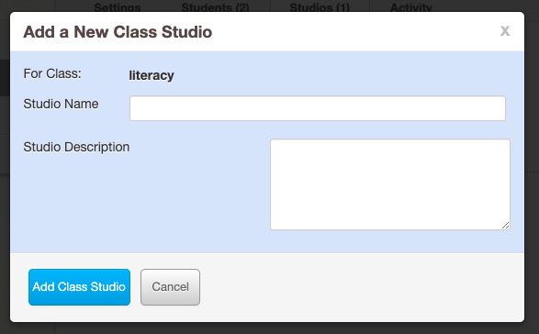

**Adding Students’ Scratch Projects to the Studio and Sharing**

We are providing two ways that you can add your students’ Scratch projects to the studio.

*The students add their projects to the Studio:*

1. Click “Share” when you are done with your project.

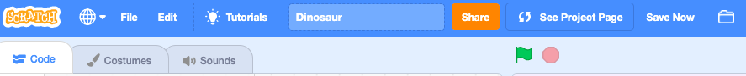

1. Choose “+ Add to Studio”.



1. Pick the designated Studio for the Unit and click “Okay”.

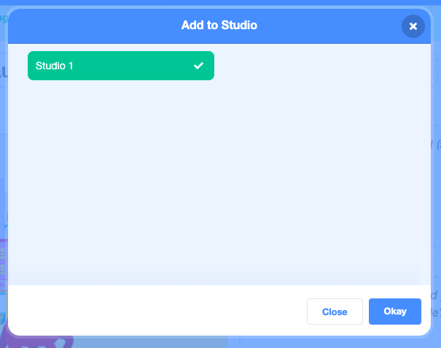

1. **Teacher** - Copy the URL at the top of your Studio page and send it to us!



*The teacher adds student projects to the Studio:*

1. Open your Studio by clicking on the studio’s name.

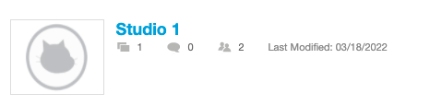

1. Choose “Browse Projects” under “Add Projects”.

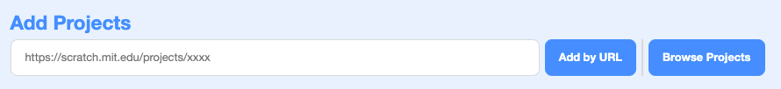

1. Go to the “Students” tab. \***Important:** If you do not see projects under your “Students” tab, it is because your students have not shared their projects. Please make sure that your students make their projects sharable.*

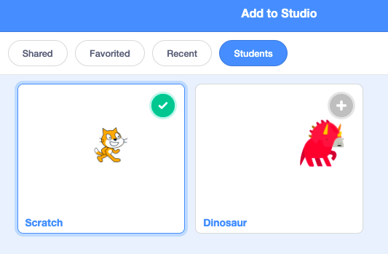

1. Click the “+” on any projects you would like to add to the Studio, then click “Done”.

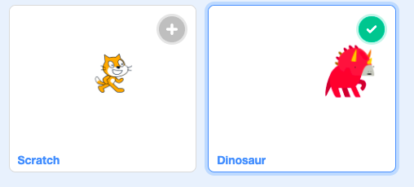

1. Copy the URL at the top of your Studio page and send it to us!

