

Lesson created by the GMU-ODU CSforAll Team. For more information about
this lesson and our CSforAll initiative, contact Dr. Amy Hutchison at achutchison1@ua.edu

Lesson 1: Pattern Recognition |  | Grade Level: K

Concept: Patterns
Vocab:
- Pattern

Summary: In this lesson, students will engage in recognizing patterns in a song, a shared reading (rhyming words), and ScratchJr blocks.

Lesson Objectives (learning targets): I can…

- Identify patterns in my environment (i.e., color patterns, big/small patterns, boy/girl, etc.)
- Follow a pattern (i.e., clapping, follow the leader, etc.)
- Identify rhyming patterns in a song or shared reading (i.e., rhyming words, word families, beginning sounds in words)
- Match rhyming word picture cards with support and/or independently

VDOE English Standard(s) | Computer Science Standard(s)
Communication and Multimodal Literacies:  K.1 The student will develop oral communication skills.  a) Listen actively and speak using agreed-upon rules for discussion.  Reading:  K.3 The student will orally identify, segment, and blend various phonemes to develop phonological and phonemic awareness.  - Begin to discriminate between spoken sentences, words, and syllables.  - Identify and produce words that rhyme.  K.4 The student will apply knowledge of how print is organized and read.  d) Read from left to right and from top to bottom.  e) Match spoken words with print.  K.6 The student will develop an understanding of basic phonetic principles.  - Demonstrate a speech-to-print match through accurate finger-point reading in familiar text that includes words with more than one syllable. | K.4 The student will categorize a group of items based on one attribute or the action of each item, with or without a computing device.

Materials
- Teacher Slides (see website)
- A class copy of Twinkle Twinkle Little Star on sentence strips, anchor chart, or screen share.
- A pointer
- Code Blocks (topional)
- Word wall cards
- Rhyming Words Star Picture Cards
- Rhyming Words Star Picture PowerPoint
- Student Checklist (optional)

Lesson Structure and Activities
(5-10 min) Warm-up/Bell Ringer Activity:

NOTE: All slides for this lesson are scripted so that, if needed, you can see exact definitions and instructions for teaching this lesson in the notes at the bottom of the teacher slide deck.

Given that this is the first lesson in the CS for ALL sequence, there is not a formal link to a prior lesson. It would be advantageous to link to students’ prior learning and knowledge of patterns, pattern recognition, and/or rhyming words where applicable. Or, skip to the anticipatory set.

(10 min) Introduction:

- Introduce Computer Science Word Wall and Patterns: show “computer science”, “computer”, and “pattern” word wall cards.

- Engagement & Interest: “Banana, Banana, Meatball” by Blazer Fresh (3 minutes)

Alternate Opening Activity in Place of ‘Banana, Banana, Meatball’ Play a game of “follow the leader.” Jump, hop, run in place, crawl, dance, etc. using a specific pattern and students follow your actions. See if they can guess a pattern. (Ex: ‘clap, clap, stomp, clap, clap, stomp’)

- Discuss Patterns: guide students to turn and talk about the pattern they see in the song with a partner or brainstorm independently. For more discussion, ask them where else they have seen a pattern. Finally, draw attention to the patterns in words (rhyming words).

(10 min) Guided Instruction:

- Introduce “Twinkle, Twinkle Little Star”: Display a copy of one of the following songs/poems on sentence strips, as an anchor chart, or via screen share. Select one that your class may already be familiar with:

    - “Twinkle, Twinkle, Little Star”*
    - “Five Little Monkeys”
    - “Five Little Ducks”
    - “Banana, Banana, Meatball”
    - “Rain, Rain, Go Away”

*For this lesson sample, we will be using and providing resources for “Twinkle, Twinkle, Little Star”. You are welcome to adapt materials for the poem of your choice.

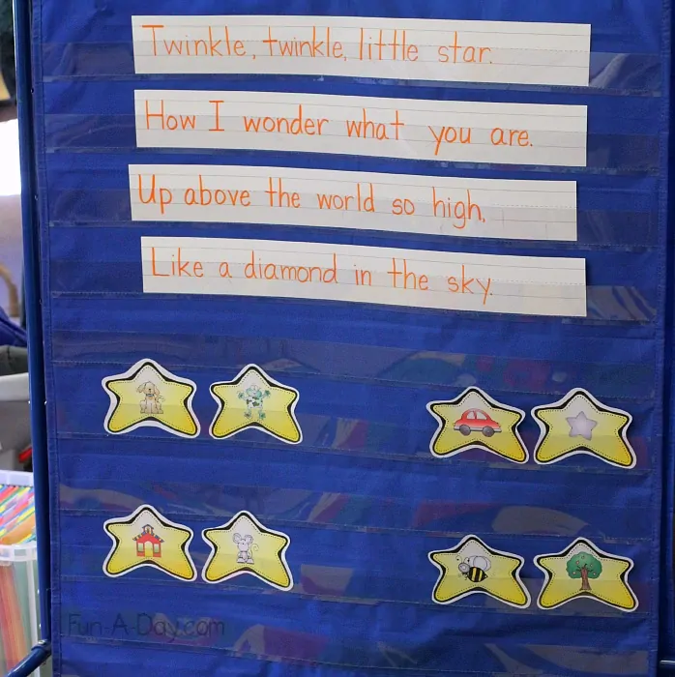

Lead class in a shared reading of the poem, modeling appropriate pacing, fluency, and one-to-one pointing. Allow students to choose to only listen, or participate in the reading

- Explain Rhyming Patterns: Read the poem again. Allow students to choose to only listen, or participate in the reading. Ask students what words sounded almost the same.

Twinkle, twinkle, little star*
How I wonder what you are*

(* indicate rhyming words by wiggling your fingers only for “star” and “are”)

（Note that some students may not make this connection right away and may need additional scaffolding to identify the first rhyming pair. In addition, rhyming is a skill that evolves across Kindergarten. Some students may not understand the concept, but they will develop their ear to hear rhyming words through exposure. Turn and Talk is a great way for students to develop this concept with a partner in a low-risk setting.）

Guide students to look for the final rhyming pair: high and sky. If needed, they can turn and talk with a partner or brainstorm independently.
(30 min) Guided Practice:

This lesson can be completed on Day 2 if needed due to time constraints/student interest. If completing on Day 2, review the core concepts from Direct Instruction (including finger wiggling cue) and reread “Twinkle Twinkle, Little Star” as a shared reading.

- Practice Finding Rhyming Patterns:
- Hold up each card, one at a time, ‘reading’ the cards to the students OR show each card on slides 17-24. This builds common vocabulary and avoids confusion in what each picture could be showing.

- Ask students to find rhyming word matches with a partner or independently and raise hands when they’re done. (You may choose to assign partners, have students self-select, divide with cooperative learning groups, or allow students to work independently)

(Distribute several sets of cards and circulate while students match OR display slide 26 and have student verbally determine the pairs

- Discuss Finding Rhyming Patterns

- After students have finished matching the cards, gather the class back together in a circle on the rug. Place all the rhyming words star picture cards face-up in the middle of the rug, evenly dispersed for students to see. Let students listen to the words and put a thumb on their knee when they find rhyming pairs (observe students who immediately indicate they’re ready and others who may be more uncertain of their ability to find rhyming words independently).

- Call on a student or allow students to volunteer to pick a rhyming pair out of the pile. Call on additional students or allow for volunteers until all pairs have been matched.

Alternate Activity to Rug Activity:
Use slides to conduct this activity on the board. Call on a student or allow students to volunteer to circle a rhyming pair on the board. Call on additional students or allow for volunteers until all pairs have been matched.

- Show coding blocks
This is an open-response whole group activity. Students can offer suggestions for various patterns with the coding blocks, using the block colors, arrow directions, or other attributes to create the pattern.
(2 min) Wrap up:

Review and summarize the patterns we learned today.

Optional: Hand out a copy of the student checklist to each student OR display it on the board. Talk about each activity you did and have students check off their progress as you talk through each one
Assessment Strategy:

The partner or independent picture sort activity is an ideal time to circulate, observe, and take brief notes on students who may need additional individual and/or small group support with rhyming. If needed, observe students completing rhyming word picture sorts in small groups during Word Study or centers.

NOTE: If students are struggling with identifying patterns in general, explicit connections in math, games and other areas may help their understanding of the concept.

Extension Ideas: | - Art: Provide bingo dotters, stickers, watercolors, or finger paints. Allow children to explore making patterns with the materials, guiding them, and modeling as necessary.  - P.E.: Play a game of “follow the leader.” Jump, hop, run in place, crawl, etc. using a specific pattern and have your child follow you. Switch roles and follow your child. (Ex: ‘clap, clap, stomp, clap, clap, stomp’)  - Music: Young children typically enjoy clapping games that require observation, mimicking of the sound pattern, and opportunities to lead the patterns themselves. Model a clapping pattern for them to copy and give them a turn, simultaneously teaching the pattern of turn-taking.  - Writing: To combine patterns and handwriting skills, invite children to choose two markers or colored pencils to use. They can practice writing letters in different color patterns. Some students may elect to use 3 or 4 colors; encourage them to remember the color pattern they’ve picked as they write.  - Science: Collect a wide assortment of natural materials, including leaves, sticks, rocks, shells, etc. Invite children to make patterns with the materials.  - Social Studies: Community helpers often have uniforms that tell other people how they help. Show children pictures of community helpers. What patterns do they notice? How are the uniforms the same and different?  - Reading: Word families also have patterns at the end of the word that helps us to read and spell. Hone students’ visual discrimination by asking them to find words in a poem, book, or sort that end the same way.
Alignment: | This is the first lesson in the unit. Lesson 2 is Sequencing.
Supplemental Resources: | Center Idea: Memory with Rhyming Words Star Picture Cards  After students have become familiar with the star picture cards, add them to the literacy center. Students can practice independently or extend their learning by playing memory. Students will place all cards face-down on the table and take turns trying to find a rhyming match. If a student finds a rhyming pair, they keep the cards. If it’s not a match, they place the cards back in the same position, face-down. Students continue until all rhyming pairs have been found.  Word Wall Idea: Add Star Cards  Additionally, the star cards could be labeled during interactive writing and added to the classroom word wall for students to reference.

